**Tribhuvan University**

**Institute of Science and Technology**



**Central Department of Computer Science and Information Technology**

**Kirtipur, Kathmandu**

**Computational Geometry**

**Assignment**

**Lab 1: Implementation of Geometric Objects**

**Submitted by: Submitted To:**

**Name:** Rishav Acharya **Asst. Prof. Jagdish Bhatta**

**Roll No.:** 01/077

**Date:** 20-July-2022

**Lab 1:** Write a program to implement following geometric objects

1. Point
2. Line Segment
3. Ray
4. Line

**Answer**

Code can be found on: https://colab.research.google.com/drive/1kjThFwOgLdRUP8jZpVhMdwHlo2KpQpHn

1: Point

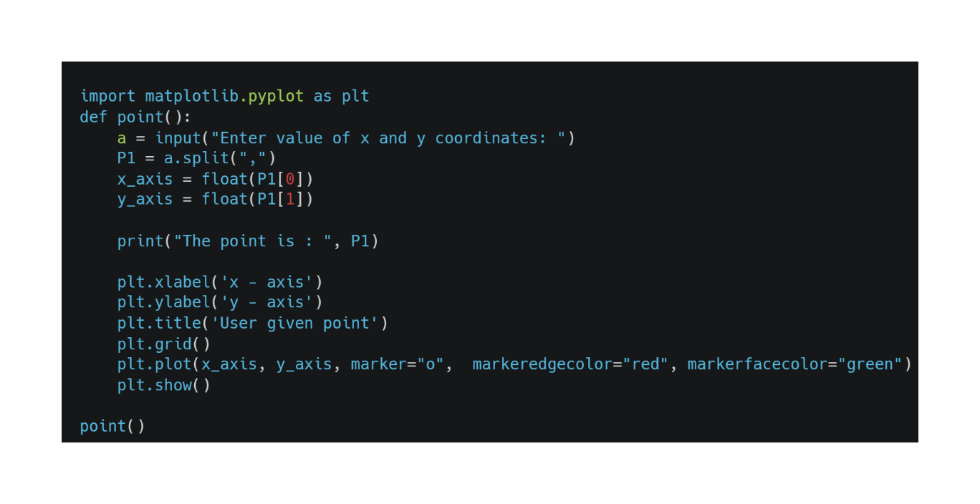

Output:

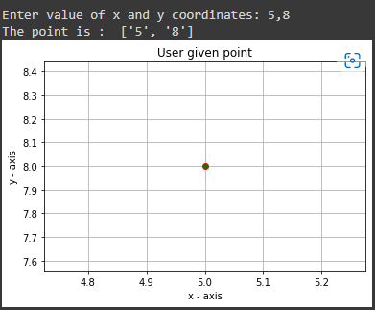

2: Line Segment

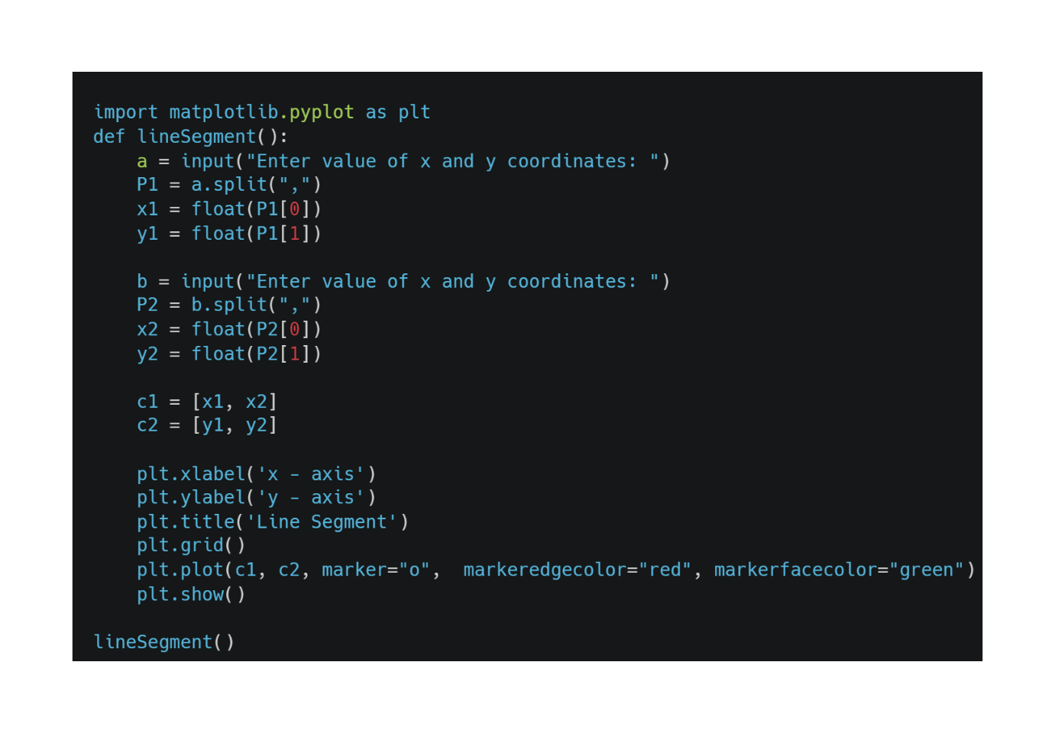

Output:

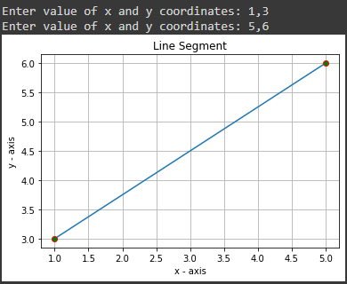

3: Ray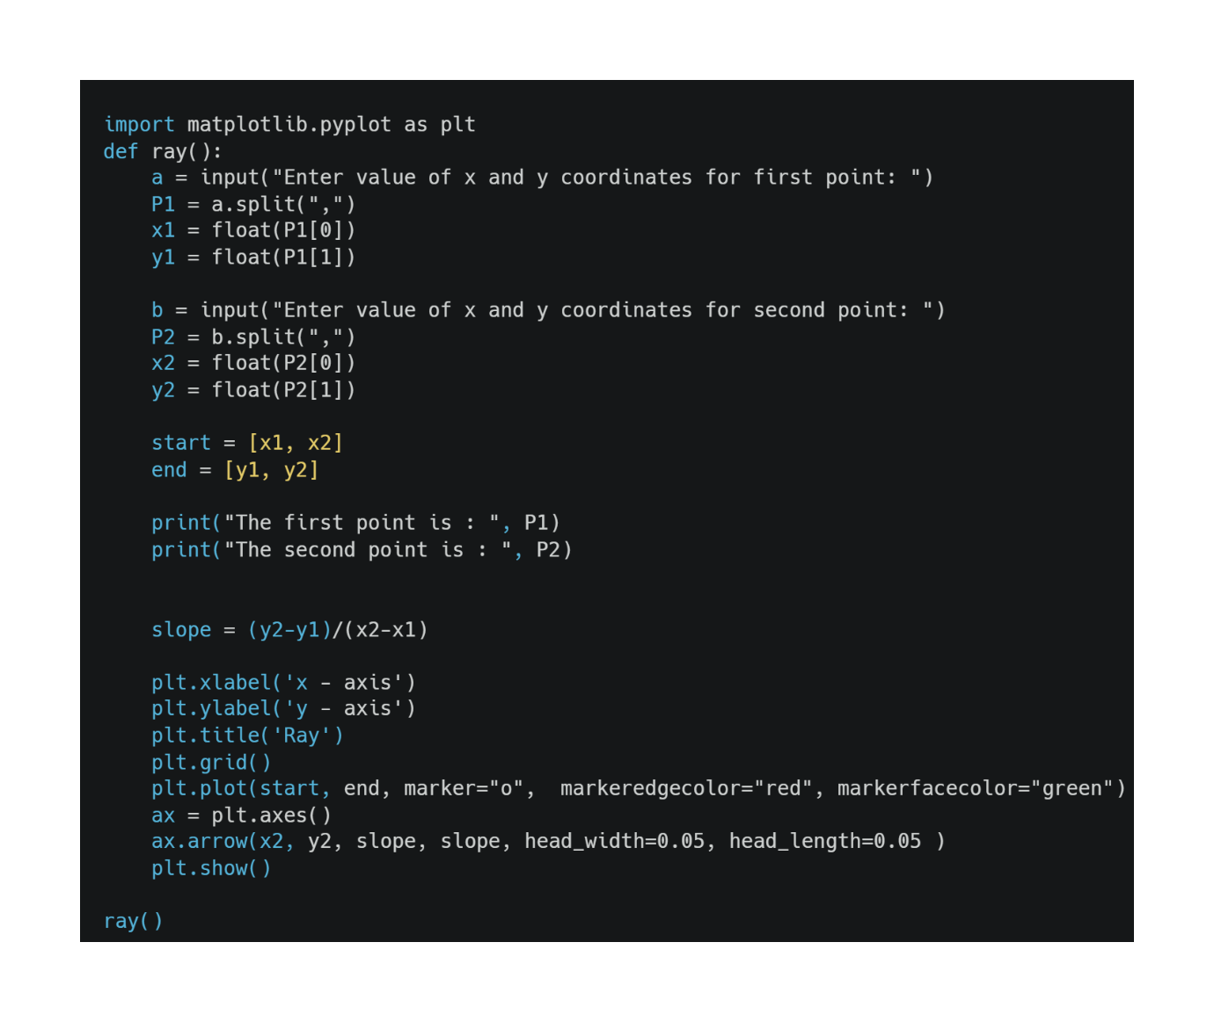Output:

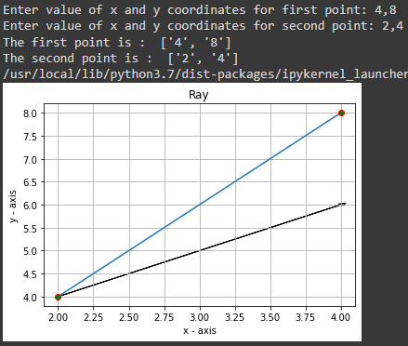

4: Line

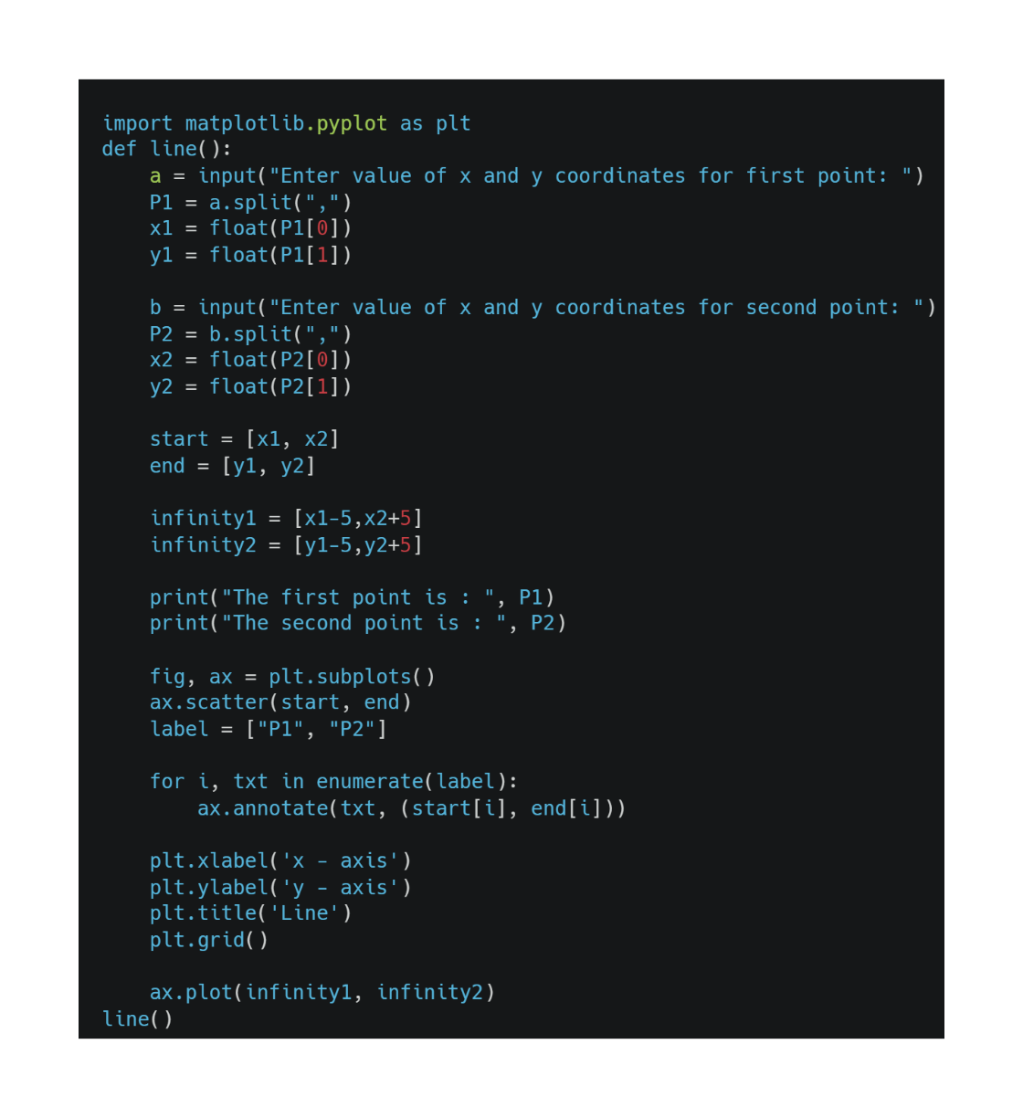

Output:

